COSC 3321 – Project report

# Team members:

Member 1: Marie Garcia

Member 2: Derius Hall

Member 3: Bennie Sofiyea

Member 4: Dalton Petersen

Member 5: Avery Bowers

Member 6: Kendall Faichtinger

Member 7: Christopher Donan

Member 8: Roman Lozano

Member 9: Erik Arrona

# Moore Finite State Machine

Place here the picture of the Moore FSM.

Add notes about abbreviations used.

# Encodings

## States:

|  |  |  |  |  |  |  |
| --- | --- | --- | --- | --- | --- | --- |
|  | **S5** | **S4** | **S3** | **S2** | **S1** | **S0** |
| **0** | 0 | 0 | 0 | 0 | 0 | 0 |
| **1** | 0 | 0 | 0 | 0 | 0 | 1 |
| **2** | 0 | 0 | 0 | 0 | 1 | 0 |
| **3** | 0 | 0 | 0 | 0 | 1 | 1 |
| **4** | 0 | 0 | 0 | 1 | 0 | 0 |
| **5** | 0 | 0 | 0 | 1 | 0 | 1 |
| **6** | 0 | 0 | 0 | 1 | 1 | 0 |
| **7** | 0 | 0 | 0 | 1 | 1 | 1 |
| **8** | 0 | 0 | 1 | 0 | 0 | 0 |
| **9** | 0 | 0 | 1 | 0 | 0 | 1 |
| **10** | 0 | 0 | 1 | 0 | 1 | 0 |
| **11** | 0 | 0 | 1 | 0 | 1 | 1 |
| **12** | 0 | 0 | 1 | 1 | 0 | 0 |
| **13** | 0 | 0 | 1 | 1 | 0 | 1 |
| **14** | 0 | 0 | 1 | 1 | 1 | 0 |
| **15** | 0 | 0 | 1 | 1 | 1 | 1 |
| **16** | 0 | 1 | 0 | 0 | 0 | 0 |
| **17** | 0 | 1 | 0 | 0 | 0 | 1 |
| **18** | 0 | 1 | 0 | 0 | 1 | 0 |
| **19** | 0 | 1 | 0 | 0 | 1 | 1 |
| **20** | 0 | 1 | 0 | 1 | 0 | 0 |
| **21** | 0 | 1 | 0 | 1 | 0 | 1 |
| **22** | 0 | 1 | 0 | 1 | 1 | 0 |
| **23** | 0 | 1 | 0 | 1 | 1 | 1 |
| **24** | 0 | 1 | 1 | 0 | 0 | 0 |
| **25** | 0 | 1 | 1 | 0 | 0 | 1 |
| **26** | 0 | 1 | 1 | 0 | 1 | 0 |
| **27** | 0 | 1 | 1 | 0 | 1 | 1 |
| **28** | 0 | 1 | 1 | 1 | 0 | 0 |
| **29** | 0 | 1 | 1 | 1 | 0 | 1 |
| **30** | 0 | 1 | 1 | 1 | 1 | 0 |
| **31** | 0 | 1 | 1 | 1 | 1 | 1 |
| **32** | 1 | 0 | 0 | 0 | 0 | 0 |

## State cont.:

|  |  |  |  |  |  |  |
| --- | --- | --- | --- | --- | --- | --- |
|  | **S5** | **S4** | **S3** | **S2** | **S1** | **S0** |
| **33** | 1 | 0 | 0 | 0 | 0 | 1 |
| **34** | 1 | 0 | 0 | 0 | 1 | 0 |
| **35** | 1 | 0 | 0 | 0 | 1 | 1 |
| **36** | 1 | 0 | 0 | 1 | 0 | 0 |
| **37** | 1 | 0 | 0 | 1 | 0 | 1 |
| **38** | 1 | 0 | 0 | 1 | 1 | 0 |
| **40** | 1 | 0 | 1 | 0 | 0 | 0 |
| **41** | 1 | 0 | 1 | 0 | 0 | 1 |
| **42** | 1 | 0 | 1 | 0 | 1 | 0 |
| **43** | 1 | 0 | 1 | 0 | 1 | 1 |
| **44** | 1 | 0 | 1 | 1 | 0 | 0 |

## Counter:

|  |  |  |  |  |
| --- | --- | --- | --- | --- |
|  | **C3** | **C2** | **C1** | **C0** |
| **0** | 0 | 0 | 0 | 0 |
| **1** | 0 | 0 | 0 | 1 |
| **2** | 0 | 0 | 1 | 0 |
| **3** | 0 | 0 | 1 | 1 |
| **4** | 0 | 1 | 0 | 0 |
| **5** | 0 | 1 | 0 | 1 |
| **6** | 0 | 1 | 1 | 0 |
| **7** | 0 | 1 | 1 | 1 |
| **8** | 1 | 0 | 0 | 0 |
| **9** | 1 | 0 | 0 | 1 |

# Light:

|  |  |  |
| --- | --- | --- |
|  | L1 | L0 |
| **Green** | 0 | 0 |
| **Yellow** | 0 | 1 |
| **Red** | 1 | 0 |

# Car:

|  |  |  |
| --- | --- | --- |
|  | E | X |
| **NO** | 0 | 0 |
| **Yes** | 1 | 1 |

# Counters

<https://onedrive.live.com/edit.aspx?resid=ADA187DA6CBE3007!1938&ithint=file%2cxlsx&authkey=!AMTfej4tgkGN1Rk>

# State Transitions/State To Outputs Table

<https://myshsu-my.sharepoint.com/:x:/g/personal/cmd106_shsu_edu/EXwUfqMLJgdIqxN14MlVemYBTaKThpQ1WERWJPRJud0lmg?e=FEgb4S>

# State Transition Boolean Equations

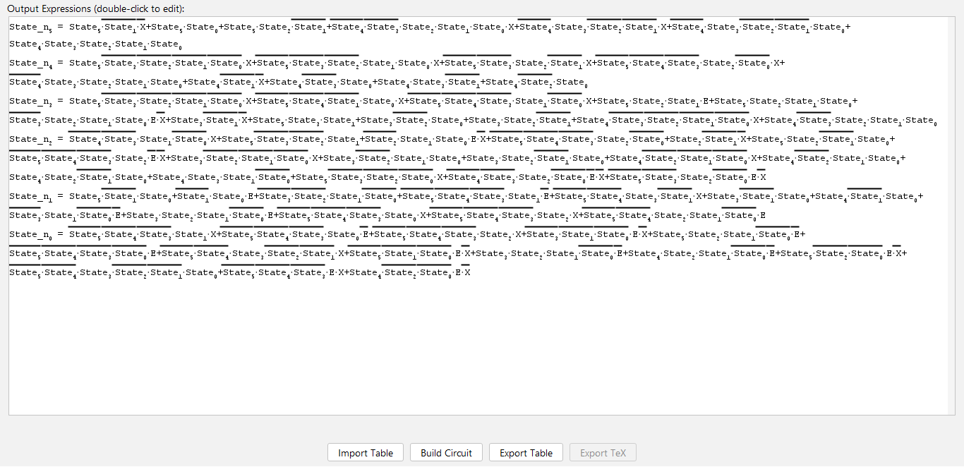

# State To Outputs Boolean Equations

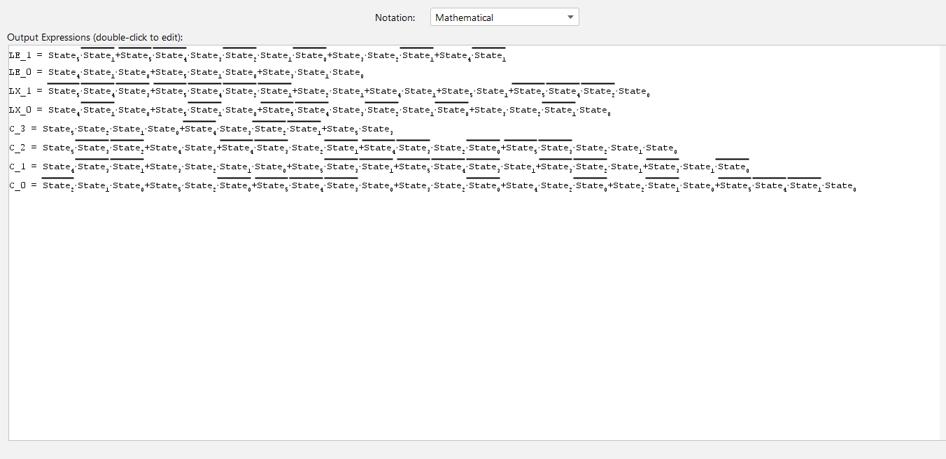

# Implementation

Place pictures of the main components of our implementation.

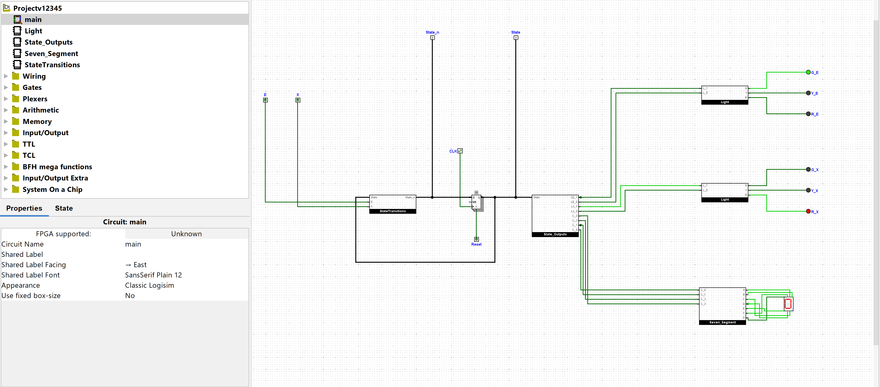

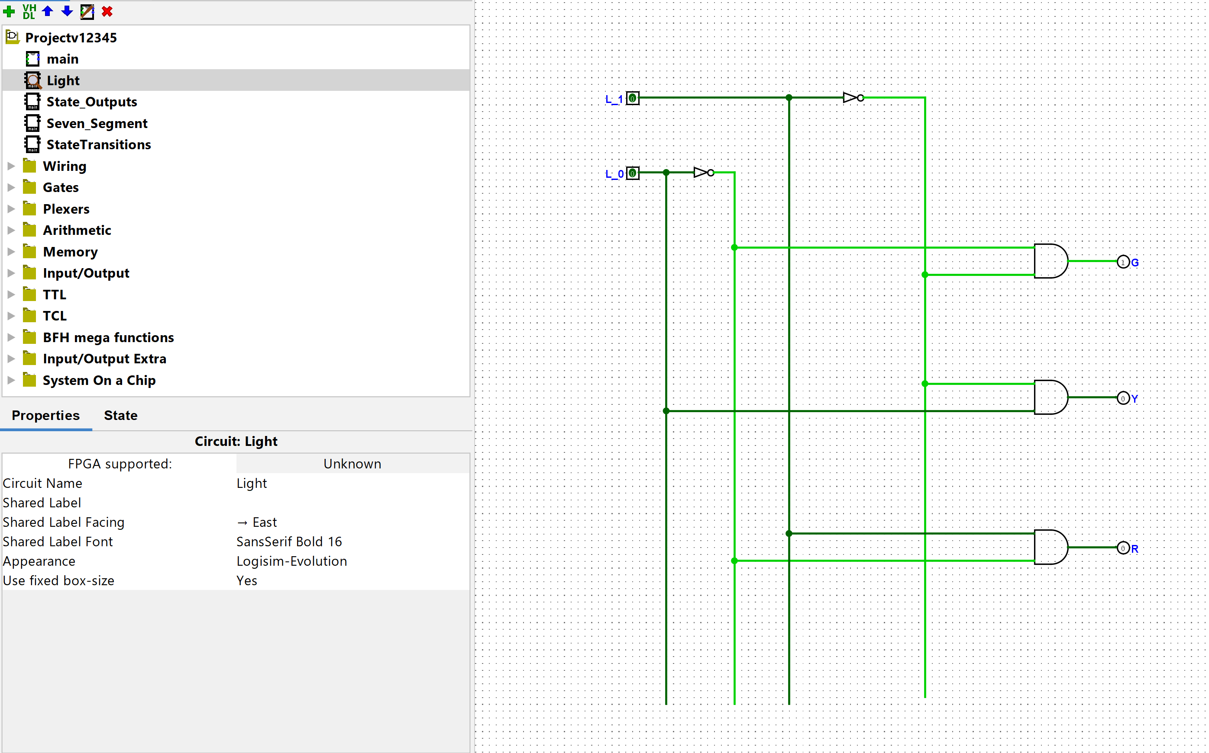

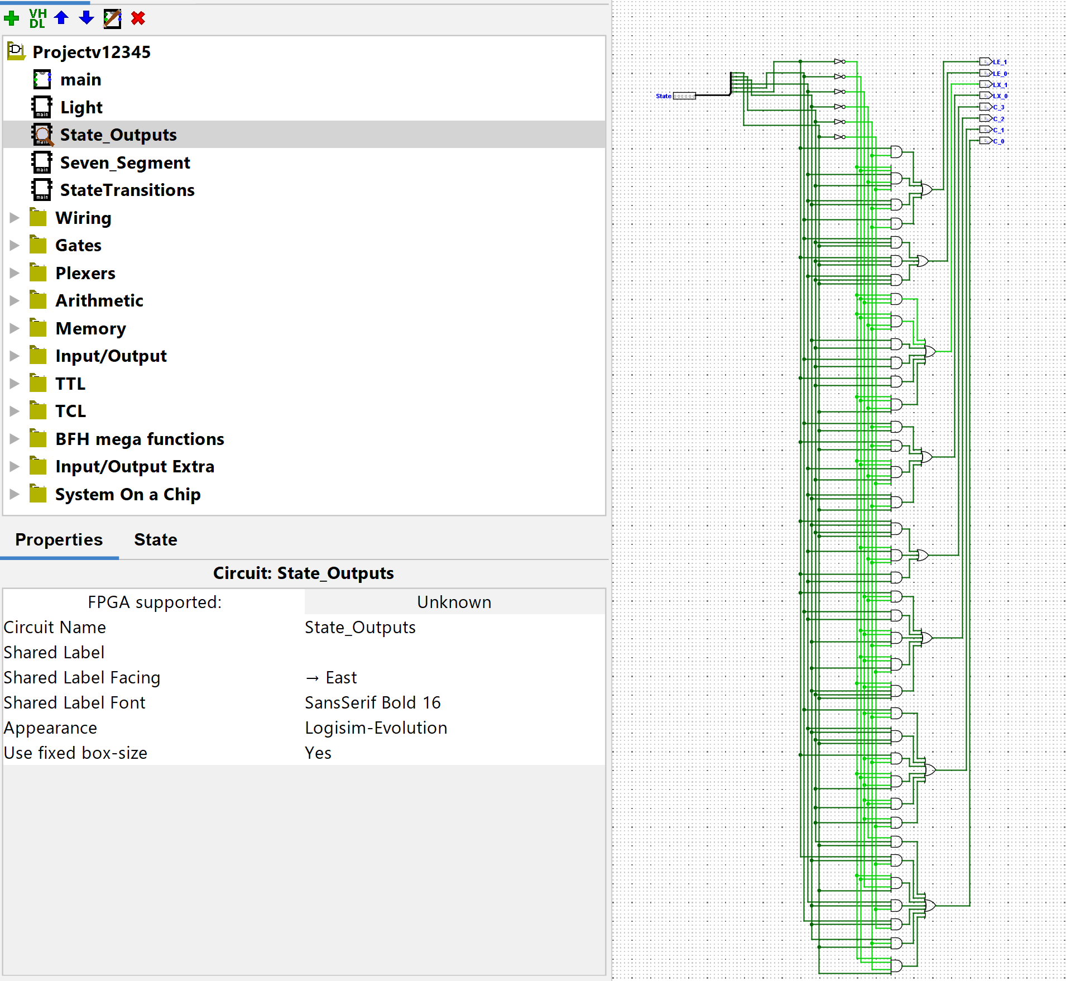

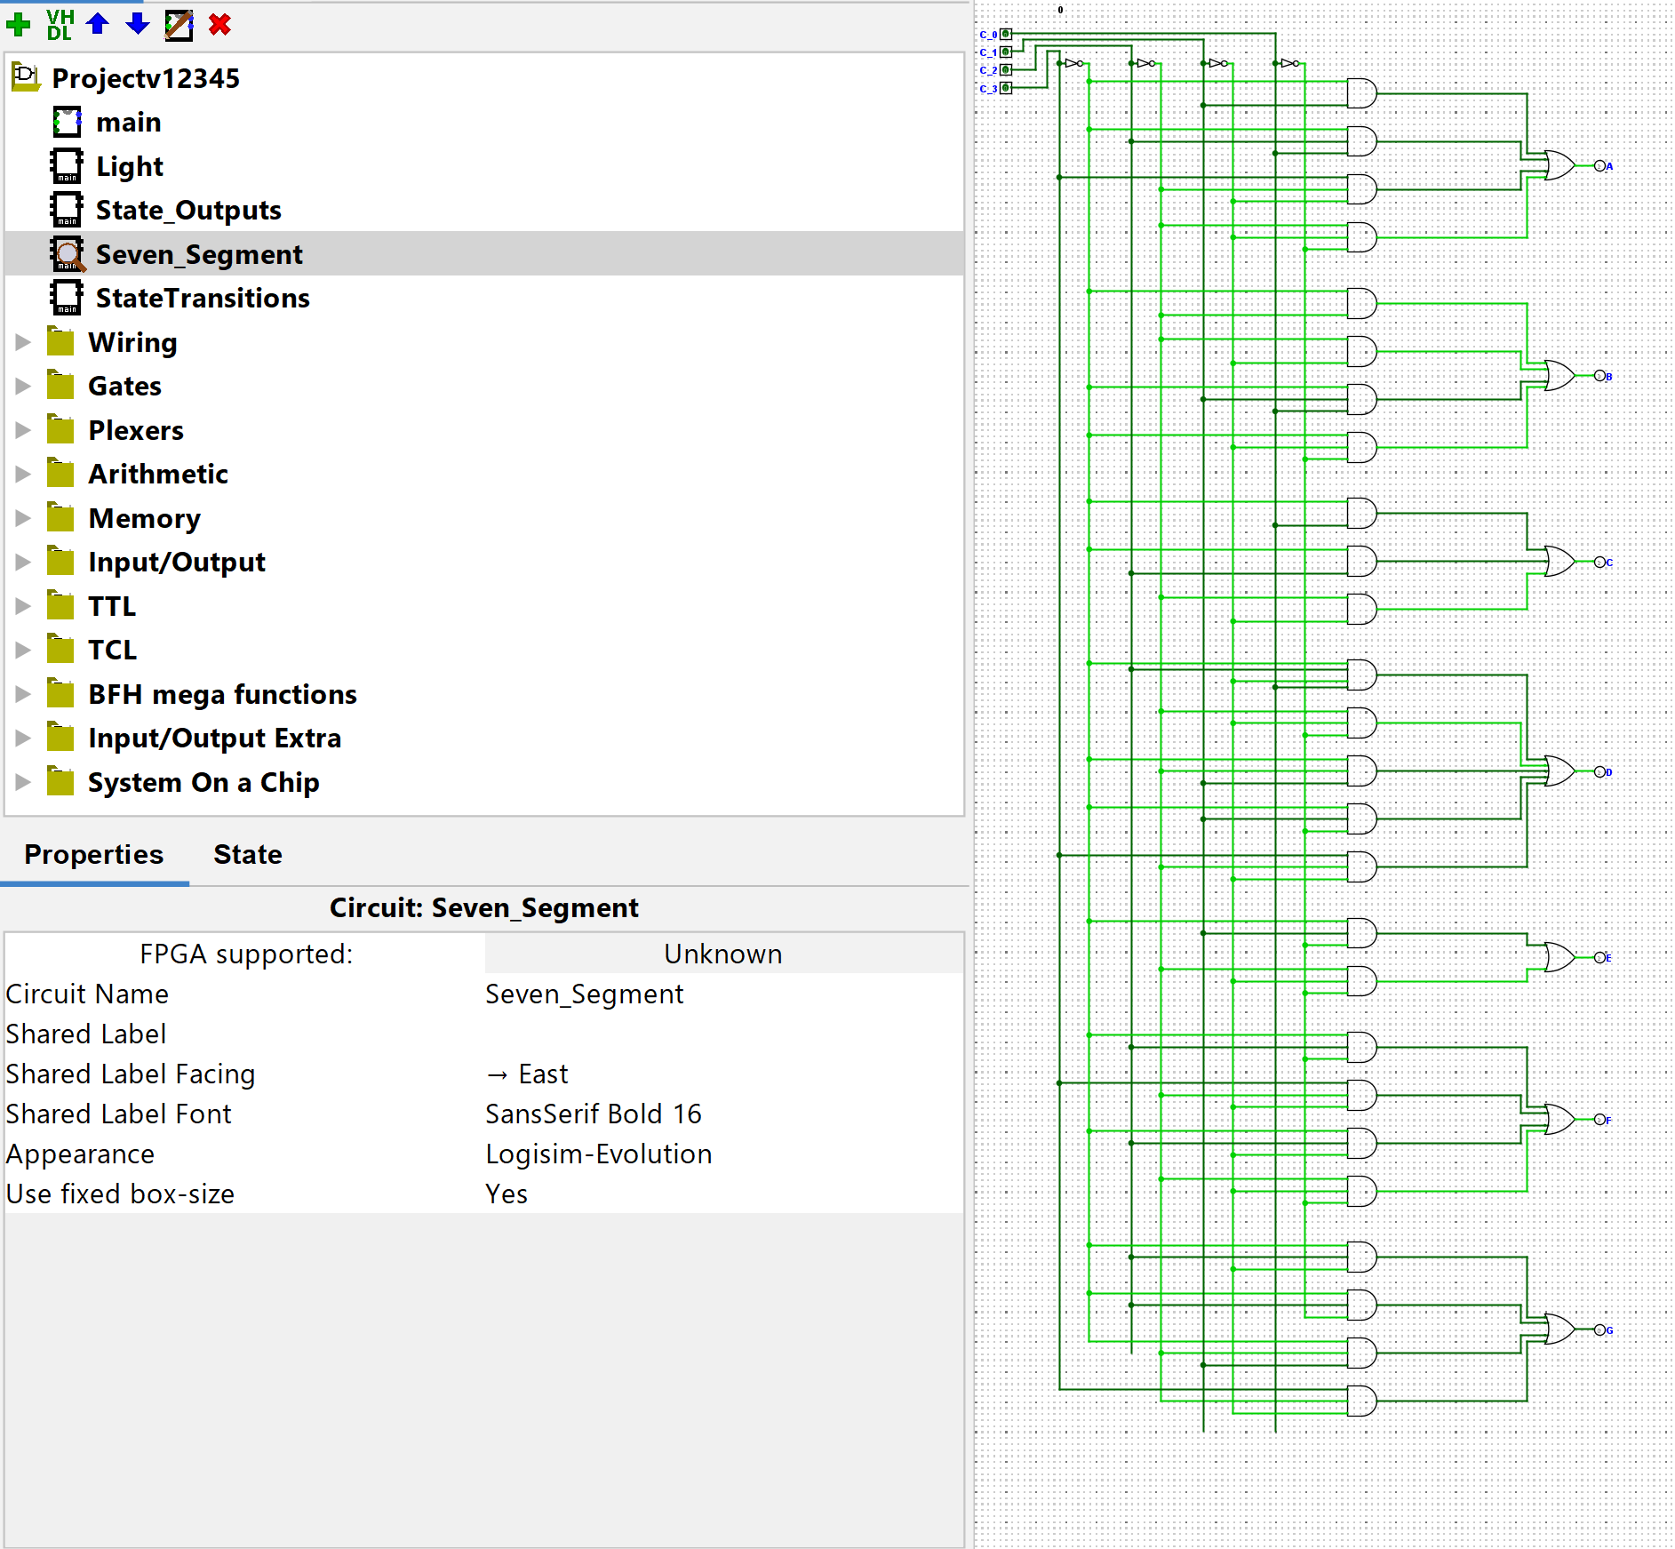

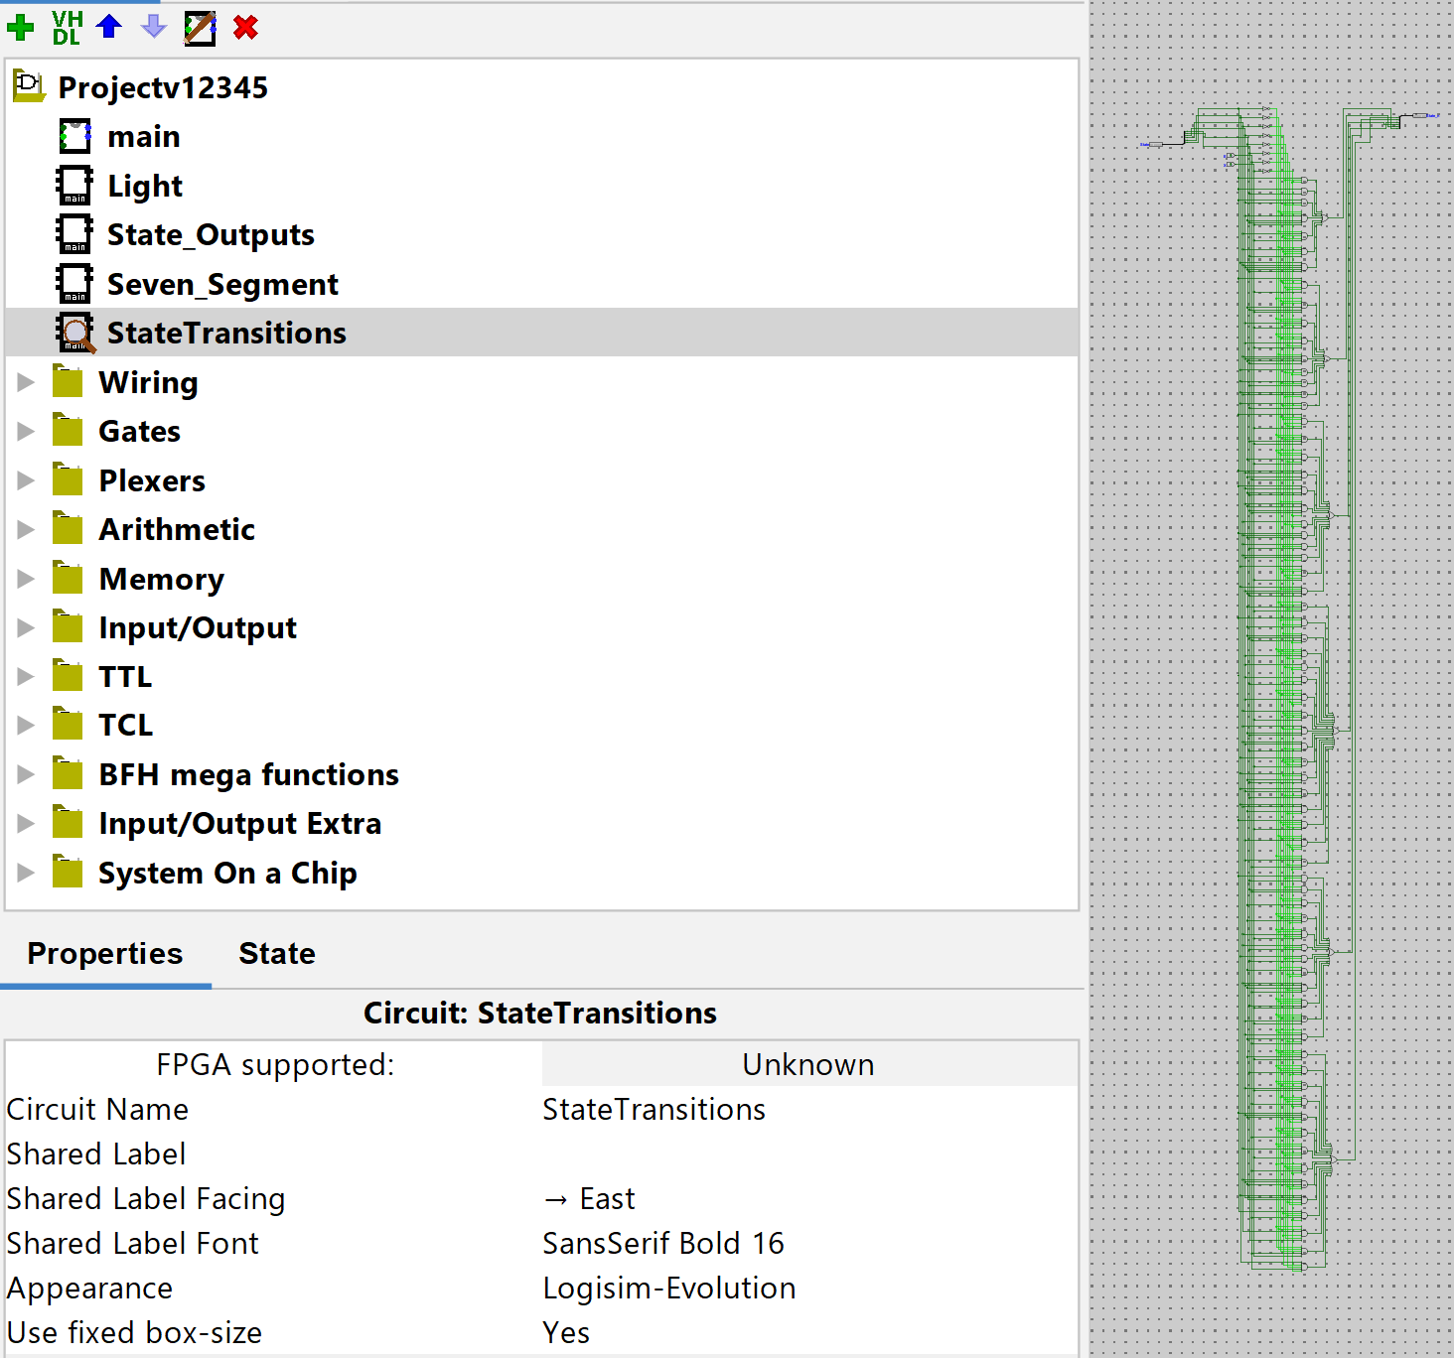

# Test cases

**Case 1: (Passed)**

Step 1: Reset, Output: C:0, LE:G, LX:R

Step 2: Set E to 1 and X= 0 then click the clock until the count equals 8.

Step 3: Click the clock one more time. Output: C:9, LE:G, LX:R

Step 4: Click the clock once. Output: C:9, LE:G, LX:R

Step 5: Set X = 1, then the clock on when the C:9: L:Y,LX:R

Step 6: Set X and E = 0 and click the clock a few times. Output: C:9, LE:R, LX:G

Step 7: Set X = 1 and click the clock. Output: C:8, LE:R, LX:G

**Case 2: (Passed)**

Step 1: Reset, Output: C:0, LE:G, LX:R

Step 2: Set E= 0, and click the clock several times, the output should the remain the same: C:0, LE:G, LX: R

Step 3: Set E = 1 , toggle the clock to 1, C:1, LE:G, Lx:R

Step 4: Set E = 0, X = 0, and toggle the clk several times and show the same output as step 3

Step 5: See X = 1 and toggle the clk twice, C:1, LE: Y, Lx:R

Step 6: Toggle the clock once, output Clk: 1, Le:R, Lx: G

Step 7: Set E= 0, X= 0, toggle the Clk several times and it should remain the same as Step 6

Step 8: Set X = 1, Toggle the Clk: 1 , Output: C: 0, Le: R, Lx:Y

Step 9: set X= 1 Toggle the CLk: 1. Output: C:0, Le: G, Lx: R

**Case 3: (Passed)**

Step 1: Reset, Output: C:0, LE:G, LX:R

Step 2: Set E to 1 and X= 0 then click the clock until the count equals 8.

Step 3: Click the clock one more time. Output: C:9, LE:G, LX:R

Step 4: Click the clock once. Output: C:9, LE:G, LX:R

Step 5: Set X = 1, then the clock on when the C:9: LE:Y,LX:R

Step 6: Set X and E = 0 and click the clock a few times. Output: C:9, LE:R, LX:G

Step 7: Set X = 1 and click the clock. Output: C:8, LE:R, LX:G

Step 8: Set X= 1 and set Clk: 1. Output: C:8, LE: R, LX: G

Step 9: Set X= 0 and E=0, Toggle the Clk Several Times: C:8, LE:R, LX:G

Step 10: Set X= 0 and E= 1, Toggle the Clk: 1: C:8, LE:R, Lx:Y

Step 11: Set X = 0 and E=1, Toggle the off and on. Output: C: 8, Le:G , Lx:R

Step 12: Set E = 0 and X=0, Toggle the CLk. Output: C:8, Le: G, Lx:R

Step 13: Set X = 1, Toggle the CLk. Output: C:8, Le: Y, Lx: R

Step 14: Set X= 1, Toggle the Clk. Output: C: 8, Le: R, Lx: G

Step 15: Set X=0 and Set E=1, Toggle the Clk; C: 8, Le: R, Lx: Y

Step 16: Set X= 0 and Set E=1, Toggle the Clk; C: 8 Le: G, Lx:Y

Step 17: Set X= 0 and Set E=1, Toggle the Clk; C:9, Le:G, Lx: R

**Case 4: PASSED**

Step 1: Reset, Output: C:0, LE:G, LX:R

Step 2: Set E to 1 and X= 0 then click the clock to count 2

Step 3: Set E to 1 and X = 1 then click the clock. C:2, LE:Y, LX:R

Step 4: Toggle clock, C:2, LE:R, LX:G

Step 5: Set E to 1, X=0, toggle clock, C:2, LE:R, LX:Y

Step 6: Toggle clock, C:2, LE:G, LX:R

Step 7: Set E=0, toggle clock, C:2, LE:G, LX:R

Step 8: Set E=1, X=0, Toggle clock, C:3, LE:G, LX:R

Step 9: Set E=1, X=1, toggle clock, C: 3, LE:Y, LX:R

Step 10: Toggle clock, C : 3, LE:R, LX:G

Step 11: Set E=0, X=0, toggle clock. C: 3, LE:R, LX:G, in S20 still

# Team member contributions:

<https://myshsu-my.sharepoint.com/:x:/g/personal/kmg147_shsu_edu/EcJSMifVisROlglpR6U2AcEBkKe1updk2akwhoXb-MgGTQ?e=gcPXWt>